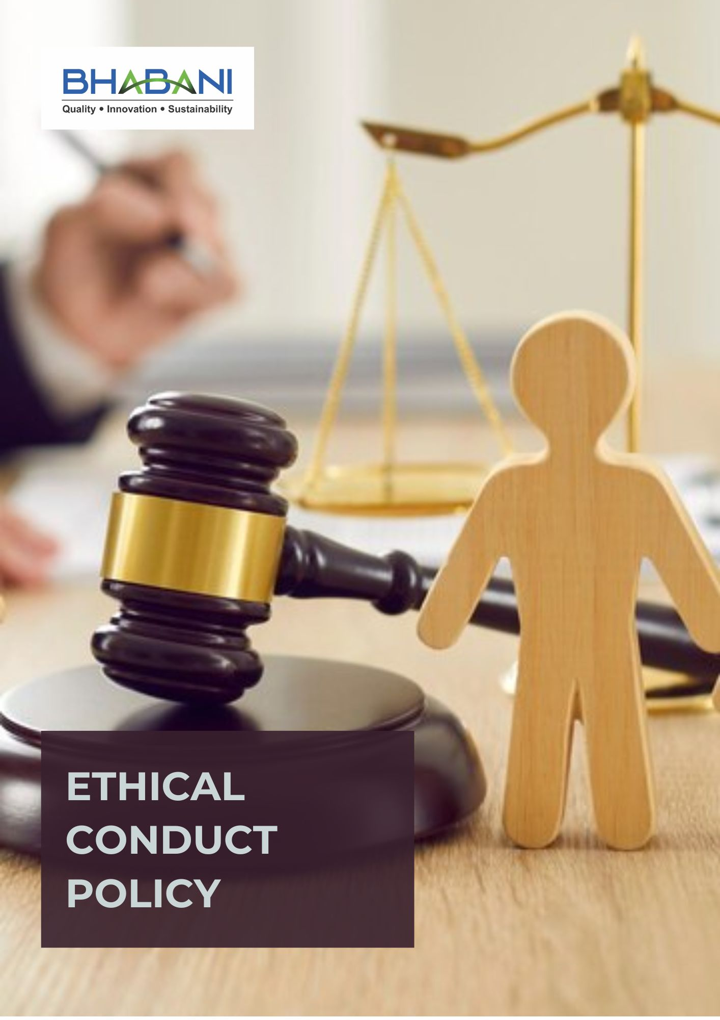

TABLE OF CONTENTS
PREFACE 2
POLICY DECLARATION 2
SCOPE 2
KEY FOCUS AREAS 3
QUALITATIVE OBJECTIVES 3
QUANTITATIVE TARGETS 4
ALIGNMENT WITH THE UNITED NATIONS SUSTAINABLE DEVELOPMENT GOALS (SDGS) 5
EXAMPLES AND GUIDANCE 6
CONTINUOUS IMPROVEMENT 7
ADDRESSING POLICY VIOLATIONS 8
RESPONSIBILITIES 8
REVIEW MECHANISM 9
EMPLOYEE ACKNOWLEDGMENT FORM 10

PREFACE

Bhabani Colors Pvt. Ltd. is committed to upholding the highest standards of ethical conduct across all its operations. The Company recognizes that ethical behavior is fundamental to long-term sustainability, business credibility, and organizational reputation. This policy defines the core principles that guide conduct and decision-making, ensuring integrity, transparency, and accountability in all interactions with employees, business partners, and stakeholders. These standards form an integral part of the Company’s governance framework and organizational culture.

Through consistent adherence to ethical principles, Bhabani Colors Pvt. Ltd. seeks to build trusted relationships with employees, customers, suppliers, and the wider community. A strong ethical foundation supports responsible business practices, strengthens stakeholder confidence, and contributes to a fair, respectful, and responsible working environment across all operations.

POLICY DECLARATION

Bhabani Colors Pvt. Ltd. establishes a zero-tolerance approach toward unethical conduct in all business activities. The Company commits to preventing corrupt practices, improper influence, financial misconduct, and misuse of information through strong governance, internal controls, and compliance systems. Safeguarding information assets and ensuring responsible data handling form a core part of this commitment. This policy serves as a binding framework for lawful, responsible, and accountable conduct across all operations and business relationships.

SCOPE

This Ethical Conduct Policy applies to all employees, contract workers, consultants, and representatives of Bhabani Colors Pvt. Ltd. and governs conduct across all business functions and operations, including manufacturing, quality control, procurement, sales, logistics, and customer interactions. It also extends to all engagements with suppliers, vendors, service providers, contractors, and other external stakeholders, ensuring that every business relationship is conducted in accordance with the Company’s principles of integrity, accountability, and ethical responsibility :

Sr. No. | Site | Address
1 | Bhabani Colors Pvt. Ltd. | A-30/BI, Mohan Cooperative Industrial Estate, New Delhi - 110044
1 | Bhabani Colors Pvt. Ltd. | SP7, MIA, Alwar - 301030, Rajasthan

KEY FOCUS AREAS
- Anti-Corruption: Prevent bribery and corruption in all business dealings through strong policies, training, and transparent reporting systems.
- Conflict of Interest: Ensure employees act in the company’s best interest by identifying and managing conflicts transparently.
- Fraud Prevention: Detect, prevent, and respond to fraud through monitoring systems and employee accountability.
- Anti-Money Laundering (AML): Strengthen financial oversight systems to prevent money laundering and suspicious transactions.
- Information Security: Safeguard sensitive information through strong data protection systems and legal compliance.
- Use of Company Assets: Ensure assets are used responsibly, efficiently, and solely for legitimate business purposes.

QUALITATIVE OBJECTIVES
- Anti-Corruption
- To enforce a zero-tolerance policy for bribery and corruption in all business transactions and provide annual training for all employees on identifying and reporting corrupt practices.

- Conflict of Interest
- Ensure implementation of clear procedures for handling potential conflicts of interest fairly and impartially.
- Promote a culture of transparency, encouraging employees to avoid situations where personal interests could conflict with business interests

- Fraud Prevention
- Provide training on identifying, preventing, and reporting fraud to all employees and encourage a culture of accountability, where fraudulent activities are promptly reported and addressed.

- Anti-Money Laundering (AML)
- Comply with all relevant AML laws, regulations, and internal procedures to prevent misuse of company operations.
- Ensure employees are aware of AML obligations, including monitoring transactions and recognizing warning signs.
- Maintain accurate records of transactions to support transparency and regulatory adherence.

- Information Security
- Protect confidential business, employee, and customer information through robust access controls and cyber security measures.
- Continuously assess and strengthen data protection practices to address evolving risks and regulatory requirements and thereby ensure secure handling, storage, and disposal of physical and digital information.
- Restrict access to sensitive information based on role and need-to-know principles.
- Promote employee awareness of information security responsibilities through regular training.

- Use of Company Assets
- Encourage employees to report any suspected misuse or damage promptly.
- Encourage responsible, ethical, and authorized use of company resources by all employees by monitoring asset usage to optimize efficiency and reduce risk.
- Encourage employees to report any suspected misuse or damage promptly.

QUANTITATIVE TARGETS
2024 has been designated as the reference year for all ethical governance objectives at Bhabani Colors Pvt. Ltd., including business integrity, anti-corruption, conflict of interest management, fraud prevention, and anti-money laundering. Progress will be evaluated against this baseline to drive continuous improvement, with the aim of achieving the established targets by year 2030.

- Anti-Corruption
- Ensure 100% of supplier and business partner contracts include anti-bribery and anti-corruption clauses by year 2030.
- Maintain zero confirmed incidents of corruption in internal or external audits each year.
- Provide annual anti-corruption training to 100% of employees in procurement, finance, and senior management till year 2030.

- Conflict of Interest
- Achieve 100% compliance with conflict-of-interest disclosures requirement by year 2030.
- Ensure 100% of new employees complete conflict-of-interest awareness and disclosure as part of onboarding procedures.

- Fraud Prevention
- Maintain zero confirmed fraud incidents across all operations till year 2030
- Review and enhance fraud detection mechanism and internal controls to cover 100% of critical processes by year 2030.
- Conduct annual fraud risk assessments covering 100% of high-risk functions by 2030.

- Anti-Money Laundering (AML)
- Conduct 2 AML internal audits covering 100% of relevant business units to identify and mitigate risks by year 2030.
- Implement transaction monitoring and suspicious activity detection mechanisms covering 100% of high-risk operations by year 2030.

- Information Security
- Implement encryption and security controls for 100% of sensitive data by 2030.
- Mainitain zero incidents of unauthorized data access or breaches through strengthened access controls and monitoring by year 2030.
- Ensure 100% of employees complete data protection and cybersecurity awareness training by 2030 and annually thereafter.

- Use of Company Assets
- Ensure 100% of employees handling sensitive assets receive annual training on proper use and safeguarding by 2030.
- Maintain a 100% reporting mechanism availability for employees to report suspected misuse.

ALIGNMENT WITH THE UNITED NATIONS SUSTAINABLE DEVELOPMENT GOALS (SDGS)
The sustainability objectives and performance targets align with the following Sustainable Development Goals (SDGs):


EXAMPLES AND GUIDANCE
To ensure consistent understanding and implementation of this Ethical Conduct Policy, the following examples and guidance illustrate expected behavior and practical actions for employees:

- Anti-Corruption
- Example: A supplier offers an employee a gift, cash incentive, or personal favor to influence a purchasing decision.
- Guidance: The employee must politely refuse and report the incident through the designated confidential reporting channels. All business decisions must be based on merit, compliance, and transparency, with full adherence to anti-corruption policies.
- Conflict of Interest
- Example: An employee participates in selecting a vendor owned by a relative or close associate.
- Guidance: The employee must disclose the relationship immediately and recuse themselves from the decision-making process. Transparency and early disclosure help ensure fair and impartial decisions.
- Fraud Prevention
- Example: An employee manipulates invoices, expense claims, or financial records for personal gain.
- Guidance: Any suspected fraud must be reported through confidential channels. Employees must follow internal controls and verification procedures to ensure financial integrity and accountability.
- Anti-Money Laundering (AML)
- Example: A customer insists on making large payments in cash or through unusual transaction routes without clear business justification.
- Guidance: Employees must flag and report suspicious transactions to the compliance team and follow AML screening procedures before processing such transactions.
- Information Security
- Example: An employee shares confidential company or customer data through unsecured email or with unauthorized persons.
- Guidance: Sensitive information must only be shared through secure systems and with authorized personnel. Employees must follow data protection protocols and cybersecurity practices at all times.
6. Use of Company Assets
- Example: Company vehicles, equipment, or digital resources are used for personal purposes without authorization by employees.
- Guidance: Employees must use company assets only for legitimate business purposes, follow usage policies, and promptly report any misuse, loss, or damage.

CONTINUOUS IMPROVEMENT
Bhabani Colors Pvt. Ltd. is committed to continuously enhancing its ethical standards to align with evolving business practices, regulatory requirements, and societal expectations. The Compliance officer will annually review and assess the effectiveness of its Ethical Conduct Policy through feedback from employees, stakeholders, and industry experts, periodic audits, and benchmarking against best industry practices. This approach ensures that the policy remains relevant and adaptive to emerging challenges. By fostering a culture of continuous improvement, we aim to uphold the highest standards of integrity, transparency, and accountability, ensuring that all employees are equipped to maintain ethical conduct in all aspects of their work.

ADDRESSING POLICY VIOLATIONS
Bhabani Colors Pvt. Ltd. takes policy violations seriously to uphold the highest standards of ethical conduct. Disciplinary measures may include verbal or written warnings for minor infractions, probation or suspension for recurring issues, and immediate termination for severe breaches such as fraud, bribery, or harassment. Additionally, legal action may be taken for unlawful activities. These measures ensure accountability and serve as a deterrent to unethical behavior, maintaining trust across the organization and with stakeholders.

RESPONSIBILITIES
The Compliance Officer will be responsible for compiling and preparing the annual corporate governance and ethics performance report. This will be done in coordination with the reporting given by the following:
- Compliance Officer: Oversees the implementation of the ethical conduct policies and ensures compliance with anti-corruption, conflict of interest, fraud, money laundering, and information security standards.
- HR Manager: Manages the training programs for all employees on ethical conduct, including anti-corruption, fraud prevention, and conflict-of-interest policies.
- IT Manager: Ensures the protection of company and customer data through secure information management systems and practices.
- Internal Audit Team: Conducts regular audits to assess compliance with the ethical conduct policies and identifies potential risks.
- Senior Management: Reviews ethical conduct performance, allocates resources for compliance initiatives, and ensures that ethical principles are embedded into the company culture.

REVIEW MECHANISM

The Compliance Officer, will annually review this policy to evaluate the effectiveness of the ethical conduct policy. This process includes assessing adherence to ethical standards, monitoring the implementation of anti-corruption measures, and addressing any reported incidents of unethical behavior. The review will involve analyzing internal and external audit findings, employee and stakeholder feedback, and the outcomes of ethics training programs. Based on these reviews, necessary updates to the policy or associated procedures will be implemented to strengthen the organization’s commitment to integrity, transparency, and ethical governance across all operations.

REV. No. 02

LAST REVIEW DATE: 01.01.2026 NEXT REVIEW DATE: 01.01.2027
APPROVED BY:

EMPLOYEE ACKNOWLEDGMENT FORM
I acknowledge that I have received, read, and understood the Ethical Conduct Policy of Bhabani Colors Pvt. Ltd. to uphold the principles set forth in the policy, including preventing bribery and corruption, identifying and disclosing conflicts of interest, preventing fraud, complying with anti-money laundering regulations, and protecting confidential company and client information.
I understand that it is my duty to follow this policy in all professional conduct and to report any suspected violations or unethical behavior through the company’s confidential whistleblower system or other designated channels. I am aware that any breach of this policy may result in appropriate disciplinary action agree as per company guidelines.
By signing this declaration, I confirm my personal commitment to maintaining ethical behavior, accountability, and transparency in all my responsibilities at Bhabani Colors Pvt. Ltd.

Employee Name | : _________________________
Employee ID | : _________________________
Department | : _________________________
Signature | : _________________________

